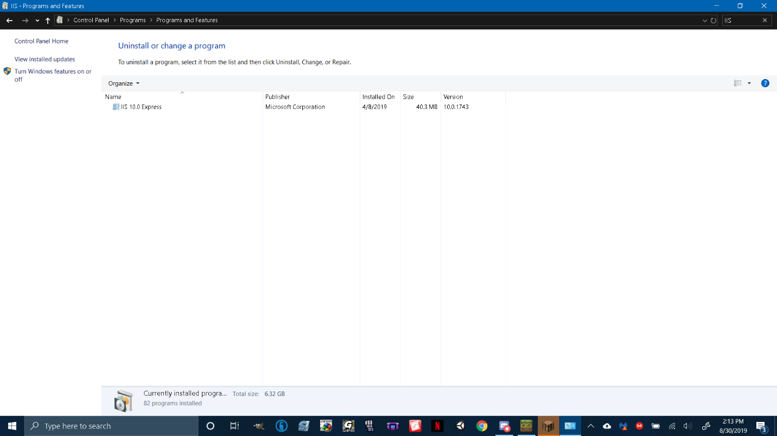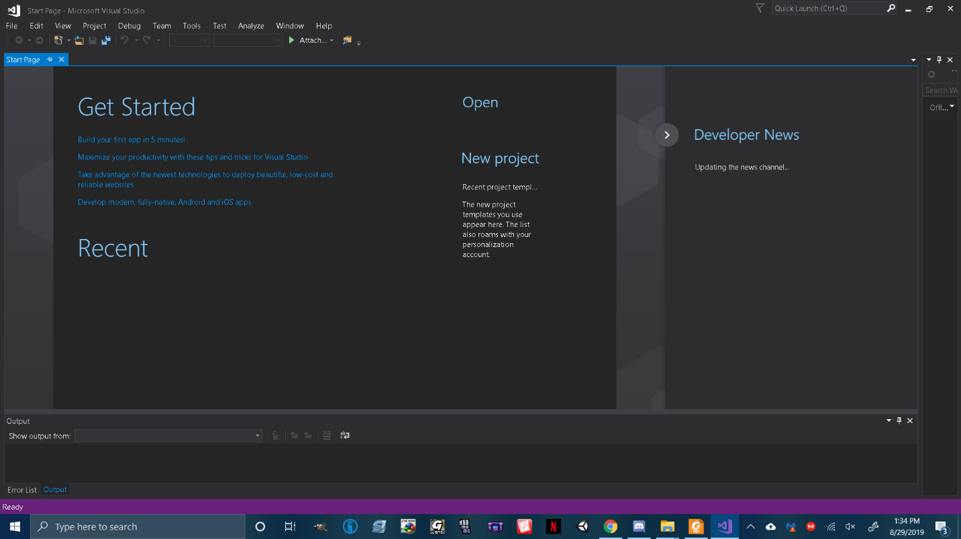

The Packaging assistant packages up the cupcakes. Later it gives the cupcakes to the Front Desk Manager. So they can deliver the cupcakes to the customer.

The Baker Makes the cupcakes and gives it to the FDM. The “Baker” is the File Server and fetches the “cupcakes” which would be data.

The Customer tells Front Desk Manager that they want cupcakes. The “Front Desk Manager” would be a Controller and would query the bakery for “Cupcakes”

The Front Desk Manager tells the Baker the customers orders. The Query System specifies what is required.

“Customer” is the User and the “Bakery” is the view. The Customer goes to the Bakery.